Name:
EGYPTIAN FRACTIONS
Fractions have a long history of use in mathematics, but they have not always been written as we see them today. About 5,000 years ago, the ancient Egyptians represented fractions using symbols. Here are some Egyptian fractions. Can you figure out how the ancient Egyptians wrote fractions?

Our Fraction | Egyptian Fraction
1. | 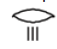
2. | 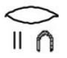
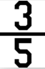  3. | 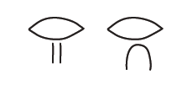
4. | 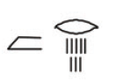
6. | This is an exception.
7.

8. Explain how you think Egyptian fractions are created.

How can you write the following fractions as Egyptian fractions?
Write the fractions using our number system.
Can you write them in more than one way?

9. 1/3

10. 2/5

11. 7/8

12. 9/10

Create your own Egyptian fractions with unit fractions

13.

14.

Create your own Egyptian fractions that have only two possible addends. Show your work.

15.

16.

Create your own Egyptian fractions that have more than two possible solutions. Show your work.

17.

18.

