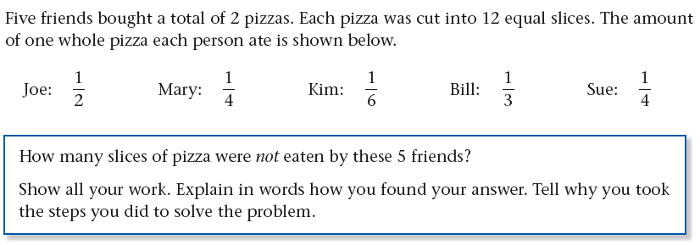

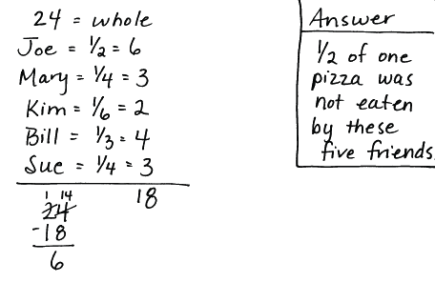
Explanation:
I need to find out how many slices of pizza were not eaten by these 5 friends. I know they had 2 pizzas cut into 12 equal slices. Each person ate a fraction of the pizza. First I turned the fraction that each person ate into whole numbers. For example, Joe ate ½ pizza. ½ of 12 slices is 6 slices It is easier to add whole number then to add fractions. Then I added the five whole numbers of slices and got 18 slices total. This is the number of slices ate total. Also since each pizza had 12 slices and there were two pizzas, I multiplied 12 x 2 to get the total number of slices. Since it asked me how many slices of pizza were not eaten by the five friends, I subtracted 18 from the whole- 24 slices. I got 6 slices which meant ½ of one pizza was not eaten by the five friends. 6 slices were not eaten by the five friends.

